STEP 1 :

RUN THE xebia-0.0.1-SNAPSHOT.jar FROM COMMAND PROMPT (FROM FOLDER WHERE JAR IS PRESENT) BY FOLLOWING COMMAND ;

java -jar xebia-0.0.1-SNAPSHOT.jar

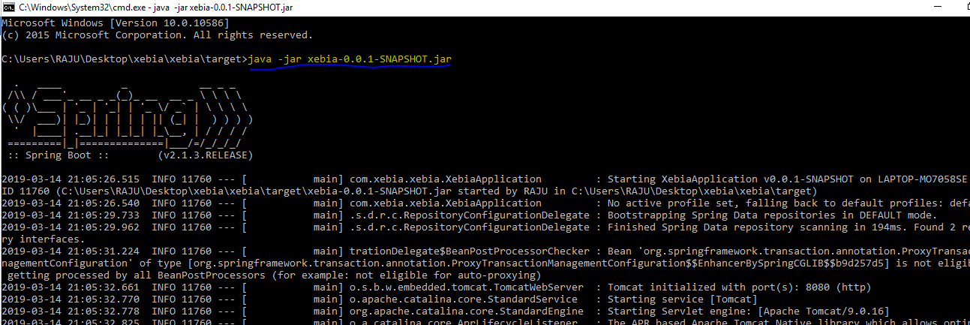

STEP 2 :

After successful start of application access the index page by following URL :

<http://localhost:8080/>

You should be able to see following page:

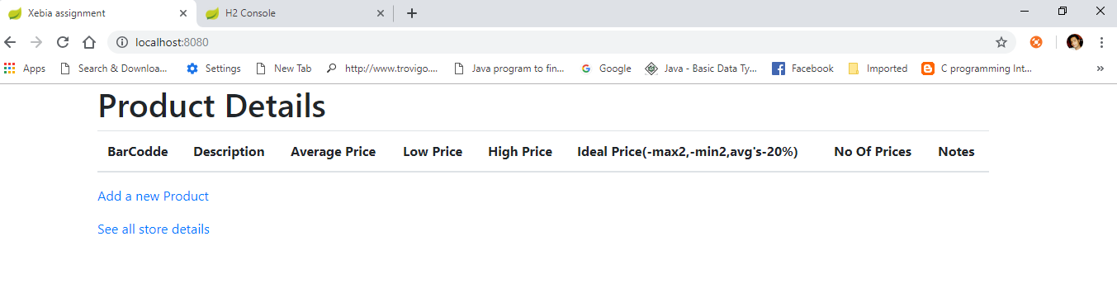

Step 3 :

Now click on Add a new Product and fill the required details.

Once particular product will be added you will be able to see the details on same page with delete option.

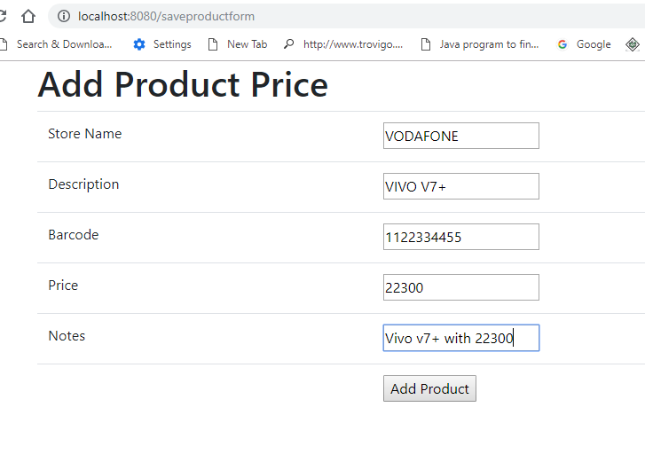

Now click on add product. After adding the new product you should be able to see all the dynmic filed data like low price, high price , average price but ideal price will be 0 as to calculate ideal price we should have at least 5 prices as to exclude 2 max and 2 min prices then take the 20% of average price.

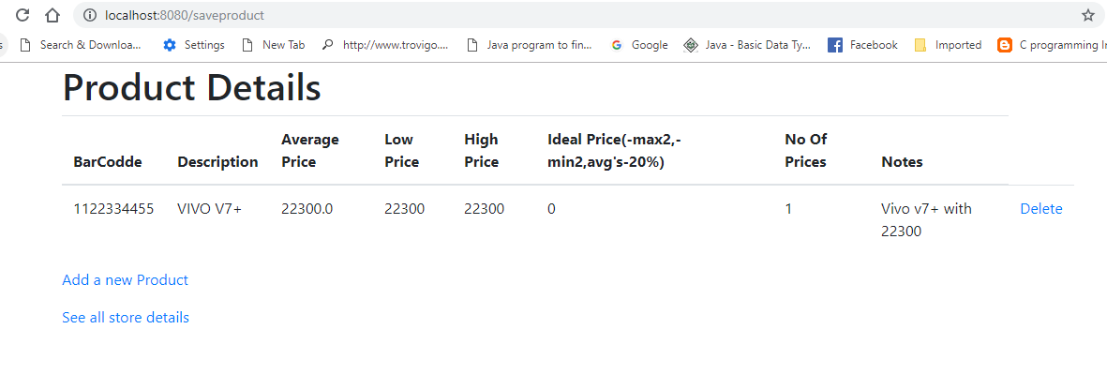

Now whenever any entry with same BARCODE will come the low price, high price , average price will change and if we have 5 or more than 5 distinct prices for same BARCODE then we will have ideal price as well.

So to uniquely identify Product we have taken the BAR CODE as unique property and while deleting the record of any product we are deleting all the records of stores and product table for that particular barcode.

Last option see all store details is to see all the prices from different stores for all bar codes.

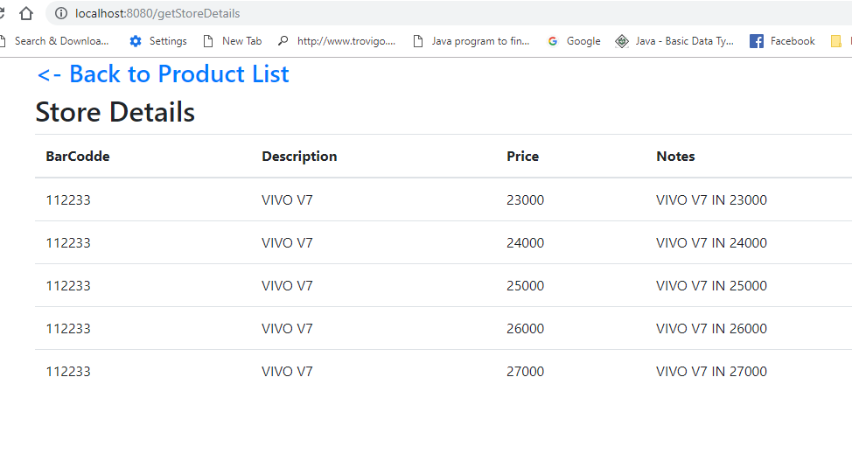

To get ideal price we need exclude 2 highest and 2 lowest price than average for remaining prices and 20% to it will be our final ideal price. So here ideal price for barcode 112233 is 30000

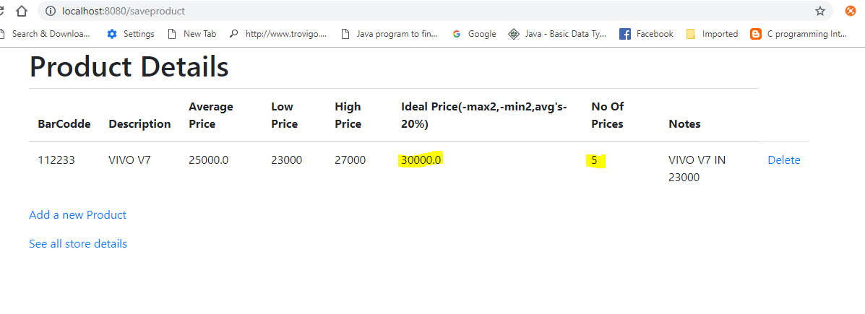

Technologies used :

1. Java 8
2. Spring boot 2.0.3 version
3. Maven
4. H2 database for in memory database
5. JPA for crud operations